Resilience  Volunteer  Youth  Corps | 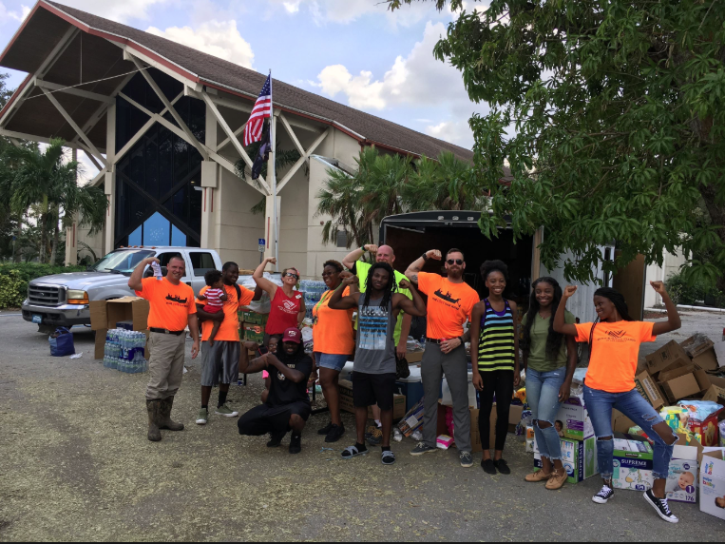
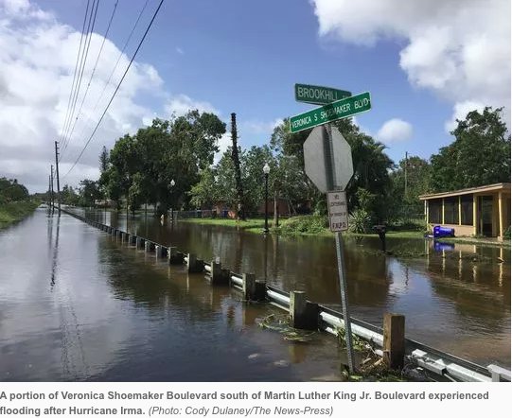 | 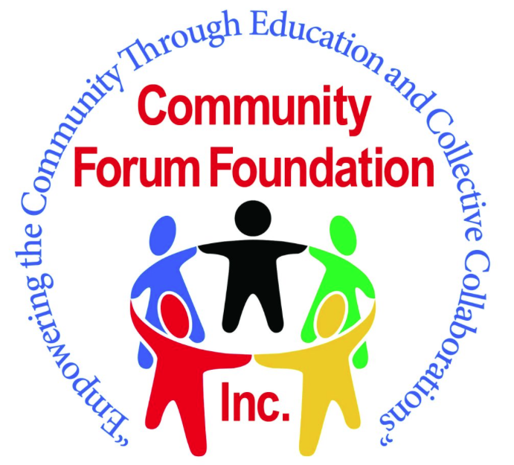

8th – 12th Grade Volunteer Training
Spring Break 2019: March 18 – 22, 2019
  - Protecting our Water to Reduce Flooding
  - Hurricane Preparedness
  - Hurricane Response
  - Community Service & Leadership Opportunities

Contact: crystalannjohnson31@yahoo.com

Overview

Protecting Our Water
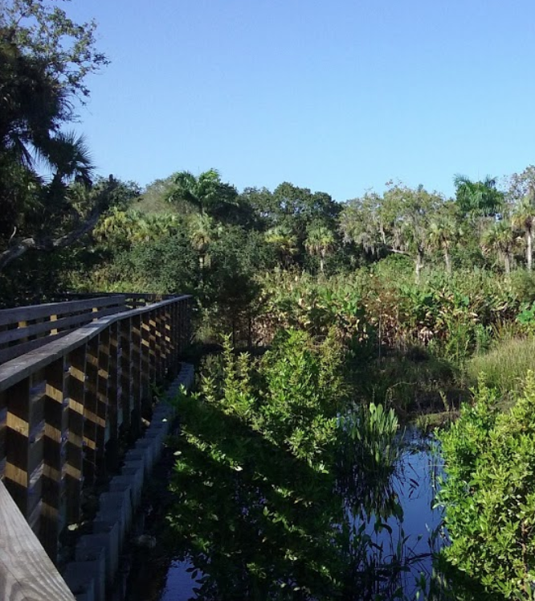
- What’s a Watershed?
- Protecting the Watershed
- Storm Drains and Flooding
- Flood Safety
- Contaminated Water Safety & Boil Water Orders

Preparedness & Response
- Your Family Emergency Plan & Preparedness Supplies
- Working with Emergency Management Operations & the Public
- Communicating in a Disaster
- Assisting the Elderly
- West Florida Resilience System
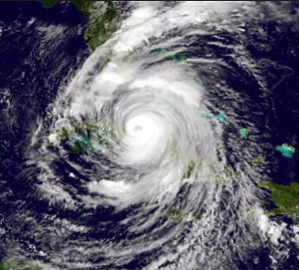
Resilience Hubs 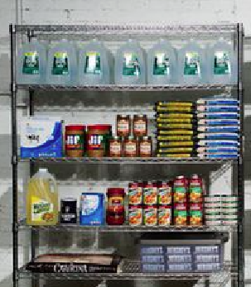
- Building Resilience
- First Aid and Protecting Human Life
- Helping Others Register to Receive Alerts & Assistance
- What You Can Do to Help
- Community Project Planning: & Supply Storage

Community Resilience Projects!
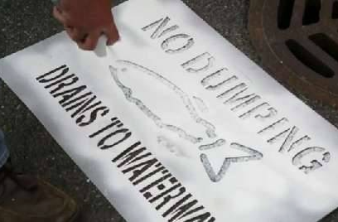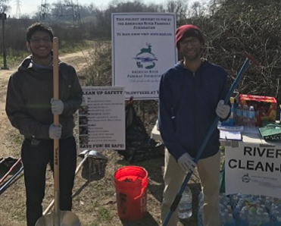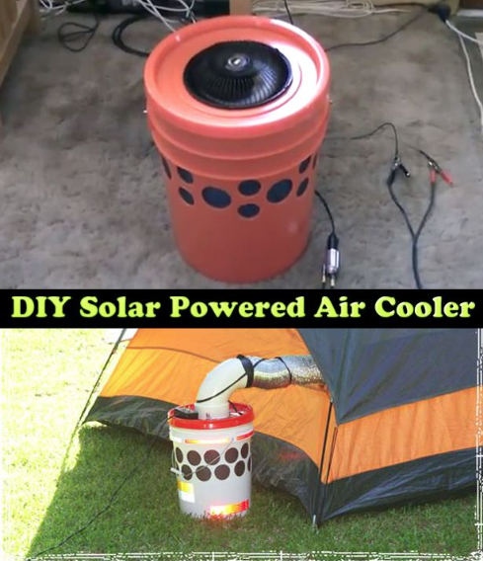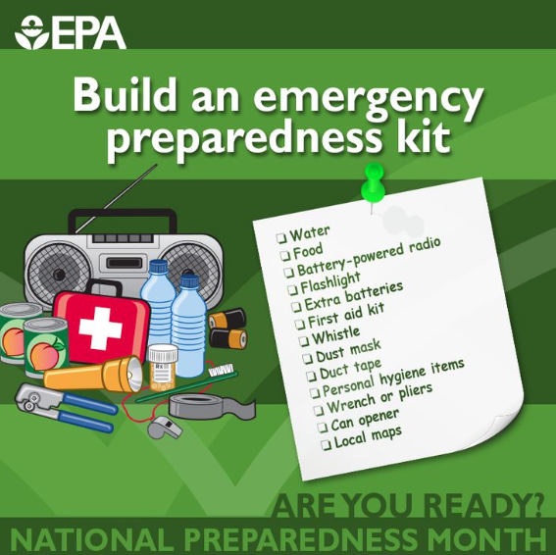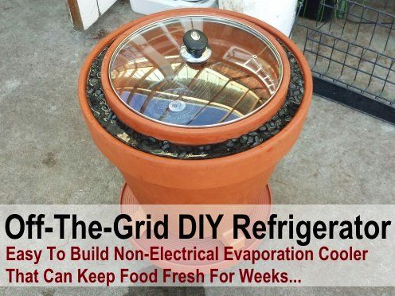
In collaboration with All Faiths Unitarian Congregation, Unitarian Universalist Church of Ft. Myers, Unitarian Universalist Congregation of Greater Naples, Pachamama Alliance of Southwest Florida and Quality Life Center, with technical support from Unitarian Universalist Justice Florida and the Florida Disaster Resilience Initiative. Thanks to our funders: The Unitarian Universalist Fund for Social Responsibility and New Florida Majority Education Fund, and to Health Initiatives Foundation, Inc. for generous technical support.

